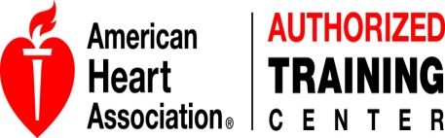
COURSE EVALUATION

COURSE DATE: ____________________________ LOCATION: __________________

COURSE NAME: ____________________________ SKILL TEST (circle one): YES NO

N/A or POOR or FAIR or GOOD or YES or
COURSE CONTENT: NO DISAGREE NEUTRAL AGREE EXCELLENT
The course learning objectives were clear
The level of difficulty was appropriate
The content was presented clearly
The quality of videos & written materials
Length of course was adequate
The equipment condition was clean and in good working condition

SKILL MASTERY:
I am confident I can apply the skills I learned
I will respond in an emergency because of the skills I learned in this course
I took this course to obtain professional education credit or continuing education credit

AHA COMPLIANCE: NO YES
I was provided/used a student manual for the course
I used a device/manikin to provide real-time measures of my compression rate and depth

INSTRUCTION:
Instructor Name: __________________________________
The Instructor answered all questions before testing
The Instructor helped during skill practice session
The Instructor was professional and courteous
Comments: ___________________________________________________________________________________________

Instructor Name: __________________________________
The Instructor answered all questions before testing
The Instructor helped during skill practice session
The Instructor was professional and courteous
Comments: ___________________________________________________________________________________________

The course prepared me to successfully pass the skills session

Have you previously taken this course via another method, such as in a classroom or online? Which learning method do you prefer and why? __________________________________________________________________________________________________________
__________________________________________________________________________________________________________
Were there any strengths or weaknesses of the course that you would like to comment on? _________________________________
__________________________________________________________________________________________________________
What would you like to see in future courses developed by the AHA? __________________________________________________
__________________________________________________________________________________________________________

.Additional comments: _______________________________________________________________________________________
__________________________________________________________________________________________________________

